CS 255 Business Requirements Document

DriverPass Training System
Dmitriy Razzhivin
Southern New Hampshire University

System Components and Design

Purpose

- The purpose of this project is to analyze, architect, and deliver a web-based, cloud-hosted enterprise driving school management platform for DriverPass.
- The client is Liam, the business owner, and Ian, the information technology officer, who seek to address a market void where over 65% of regional driver's license applicants fail their Department of Motor Vehicles practical exams.
- The system must centralize student registration, automate curriculum and practice exam delivery, handle scheduling for on-the-road training sessions across a 10-vehicle fleet, track vehicle and instructor assignments, process payments, and ensure regulatory alignment with real-time DMV policy updates.

System Background

- DriverPass identified that prospective drivers fail testing primarily due to superficial test-memorization habits rather than structured in-car training and comprehensive theory education.
- The client requires an integrated platform replacing manual bookkeeping with a cohesive solution accessible online via computer and mobile browsers, while supporting offline read-only reporting.
- An e-learning module supporting interactive online practice tests, module progression tracking, and automated scoring metrics.
- A fleet and appointment scheduling engine coordinating multi-lesson training packages across 10 company-owned vehicles and dedicated instructors.
- A role-based security subsystem governing access control for four distinct stakeholder personas: Owner, IT Administrator, Secretary, and Student.
- A financial payment processing pipeline capturing credit and debit card information during onboarding.
- An external integration gateway establishing a persistent communication link with local DMV servers for regulatory updates.
- An automated audit and logging subsystem tracking every transaction, reservation creation, cancellation, and record modification.

Objectives and Goals

- Improve student driving test pass rates through structured, blended training packages combining online learning modules with practical, hands-on driving instruction.
- Deliver an omni-channel booking and administrative system enabling students to schedule, modify, or cancel driving sessions online, while empowering office secretaries to handle identical workflows for phone and walk-in clients.
- Enforce operational traceability by capturing non-repudiation audit trails for all reservation modifications, cancellations, and user account updates.
- Maintain a cloud-hosted web architecture providing high availability, removing on-premises backup burdens from client staff and preventing multi-server data redundancy.
- Eliminate fleet double-booking errors by enforcing strict transactional constraints that map one student, one instructor, and one dedicated vehicle to a distinct two-hour time slot.

Requirements

Nonfunctional Requirements

Performance Requirements

- Cloud Hosting and Environment: The system shall run entirely within a cloud web architecture, providing responsive browser interfaces accessible across desktop, tablet, and mobile platforms without requiring local server maintenance.
- Latency and Response Times: The system shall complete user authentication, session reservation confirmations, and page state transitions within three seconds under standard broadband connections.
- Data Synchronization and Concurrency: The system shall enforce a strict online-only write model; offline access shall be limited to read-only analytical reports, such as Microsoft Excel exports, to eliminate distributed data drift and multi-server redundancy.
- Scalability and Fleet Throughput: The scheduling backend shall simultaneously process concurrent booking operations across all 10 vehicles and instructors without record deadlocks or race conditions.
- Automated Backup Schedules: The cloud infrastructure shall perform incremental hourly database backups and daily full-state snapshots with automated point-in-time recovery.

Platform Constraints

- Operating Environment: The platform must run within standard, cross-platform modern web browsers, including Chrome, Edge, Safari, and Firefox, compliant with HTML5, CSS3, and modern JavaScript standards.
- Database Engine: The backend shall utilize a relational database management system configured with foreign key constraints, ACID transaction compliance, and automated index optimization for scheduling queries.
- Network and Architecture Constraints: The system must enforce centralized server-side data validation; local offline client modifications are prohibited to prevent data desynchronization across distributed devices.
- Reporting Interoperability: All administrative, student progress, and activity audit logs must export directly into Microsoft Excel (.xlsx) and Comma-Separated Values (.csv) formats.

Accuracy and Precision

- Scheduling Precision: All in-car appointments shall be configured, scheduled, and validated in discrete two-hour blocks with absolute start and end timestamps.
- Geographic Accuracy: The system shall validate and store pickup and drop-off addresses, enforcing validation rules verifying that pickup and drop-off locations match.
- Fleet Allocation Integrity: The scheduling engine shall enforce mutually exclusive matching rules ensuring that no instructor, vehicle, or student can be assigned to multiple appointments simultaneously.
- Financial Precision: Payment amounts, package pricing, and card processing figures shall be calculated and stored to two decimal places with zero rounding discrepancies.
- Case-Sensitivity and Validation: The authentication engine shall enforce case-sensitive password strings alongside standardized, sanitized, case-insensitive email identifiers for user accounts.

Adaptability

- Administrative Role Isolation: The system shall allow the IT administrator to grant, modify, deactivate, or terminate user accounts, permissions, and roles dynamically via an administrative dashboard without altering source code.
- Service Package Flexibility: The system shall empower administrative staff to enable or disable specific training packages from public registration dynamically via database flags without recompiling or redeploying the application.
- Future Architectural Extensibility: The business logic tier shall be modularly decoupled from the presentation tier, enabling software analysts and engineers to integrate custom modules, add new curricula, or extend packages in subsequent development cycles without system redesign.
- Regulatory Integration Adaptability: The system shall incorporate an extensible web service connector capable of consuming schema updates and question bank payloads delivered by DMV notification endpoints.

Security

- Role-Based Access Control: The system shall enforce hierarchical access privileges partitioning capabilities among Owner, IT Administrator, Secretary, and Student roles.
- Authentication and Password Reset: The system shall require secure username and password authentication and provide an automated, self-service email-token password reset mechanism for authenticated users.
- Brute-Force Lockout Defense: The system shall automatically lock an account after five consecutive failed login attempts, dispatching a security warning email to the user and logging the event for administrative review.
- Data Encryption Standards: The system shall enforce TLS 1.3 encryption for all data in transit across public networks and AES-256 encryption for sensitive data at rest, including user credentials, address records, and contact details.
- Payment Security and Compliance: The system shall handle payment transactions through tokenized payment gateway APIs; raw credit card numbers, expiration dates, and CVV security codes shall never be stored within DriverPass application databases in order to maintain PCI-DSS compliance.
- Immutable Activity Audit Logging: The system shall generate immutable, append-only audit log records for all administrative events, user profile changes, reservation requests, reschedules, and cancellations, capturing user IDs, timestamps, IP addresses, and previous and updated state values.

Functional Requirements

- The system shall validate user credentials during login and establish secure, role-restricted user sessions.
- The system shall capture student onboarding data during phone, in-person, or web registration, including first name, last name, physical address, phone number, state, email, and billing information.
- The system shall capture pickup and drop-off location data, verifying that the drop-off location matches the designated pickup address.
- The system shall process package enrollments across Package One (6 hours behind the wheel across three 2-hour sessions), Package Two (8 hours behind the wheel across four 2-hour sessions plus in-person DMV policy instruction), and Package Three (12 hours behind the wheel across six 2-hour sessions, in-person DMV instruction, online coursework, and practice tests).
- The system shall provide students with self-service scheduling tools to view calendar openings, book two-hour road lessons, modify upcoming reservations, and cancel sessions within allowed policy windows.
- The system shall provide an administrative scheduling portal allowing secretaries to book, adjust, or cancel two-hour appointments for students calling or visiting the office.
- The system shall cross-reference vehicle availability and assign a specific car from the 10-car fleet and a certified driver to every booked road appointment without overlap.
- The system shall deliver online classroom curriculum, administer randomized DMV practice tests, track module completion percentages, record test duration, calculate numeric scores, and assign passing or failing statuses.
- The system shall allow instructors to input, review, and persist post-lesson evaluation notes, recorded drive hours, and qualitative student feedback.
- The system shall provide the owner with on-demand reporting engines to generate and export financial summaries, student completion statistics, vehicle utilization rates, and detailed activity logs.
- The system shall allow the IT administrator to unlock accounts, execute administrative password overrides, modify user permissions, and revoke active login sessions.
- The system shall listen for external DMV web service broadcasts, alert administrators upon new regulatory postings, and ingest updated driving rules or test questions.

User Interface

- Presentation Architecture: A responsive, mobile-first web user interface optimized for desktop workstations, tablets, and smartphones, engineered according to Liam's architectural wireframe sketch.
- Student Dashboard Interface:
  - Profile Overview Panel: Displays student portrait, full legal name, residential address, telephone number, email, and special accommodations tags.
  - Practice Exam Module: A visual progress matrix enumerating assigned online tests, test state (Not Taken, In Progress, Failed, Passed), completion duration, and historical scores.
  - Road Lesson Evaluation Table: A chronological log displaying driving dates, assigned instructor names, start and end hours, and post-session instructor notes.
  - Appointment Booking Portal: An interactive calendar interface displaying available 2-hour road time slots, vehicle selections, and appointment status controls.
- Secretary and Office Front-Desk Interface:
  - Rapid Telephone Onboarding Form: A streamlined data-entry layout allowing rapid entry of student contact information, credit card details, pickup and drop-off validation, and initial package assignment.
  - Master Scheduling Grid: A consolidated calendar view illustrating real-time vehicle deployments across all 10 cars and instructors, allowing appointment adjustments.
- Business Owner Management Interface:
  - Analytical Dashboard: High-level widgets tracking active package enrollments, fleet maintenance flags, student pass and fail trends, and revenue metrics.
  - Audit and Reporting View: Advanced filtering interface enabling export of user activity logs, cancellation histories, and staff actions directly into Microsoft Excel.
- IT Administration Dashboard:
  - Security Console: User account management portal displaying account status, role assignment dropdowns, failed login counters, session termination triggers, and security log inspectors.
  - System Configuration Panel: Package management interface allowing instant toggling of training packages and DMV endpoint connection health monitors.

Assumptions

- Network and Device Availability: All end users, including students, administrative staff, and instructors, possess Internet-enabled computing devices or smartphones operating modern, JavaScript-enabled web browsers.
- Enterprise Cloud Reliability: Cloud hosting infrastructure providers maintain network uptime exceeding 99.9% and execute automated daily disaster recovery backups.
- Third-Party Payment Gateway: An established payment merchant processor manages tokenized credit card authorization, merchant account settlements, and PCI-DSS data storage.
- Fleet and Staffing Constraints: DriverPass maintains exactly 10 fully registered, insured vehicles and a corresponding team of certified instructors available during published operational hours.
- DMV External Endpoint Interoperability: The state Department of Motor Vehicles exposes secure web APIs, feeds, or webhook endpoints capable of transmitting standardized regulatory updates and question items.
- Lesson Policy Compliance: All behind-the-wheel sessions remain fixed at precisely two hours in duration, and students consistently begin and conclude their routes at the same physical street address.

Limitations

- Offline Write Limitations: The system cannot write, update, or modify records while offline; any offline usage is strictly restricted to locally cached, read-only analytical reports to protect data integrity.
- Dynamic Package Engineering Constraints: Business owners cannot construct novel curriculum structures or dynamic modular training packages from scratch through the user interface in Version 1.0; structural additions require future software development cycles.
- Fixed Fleet Capacity: The system cannot schedule more than 10 concurrent in-car lessons at any single point in time due to physical fleet boundaries.
- Geographic Constraints: Behind-the-wheel appointments are geographically bounded by validated regional pickup zones; out-of-boundary pickup locations will be rejected by the validation logic.
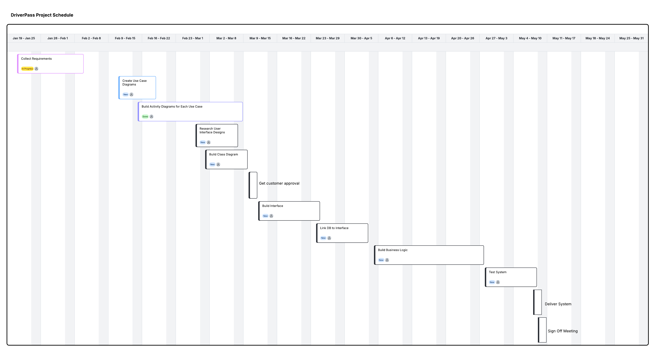
- Hardware Support Scope: The software development project does not cover on-premises workstation hardware procurement, vehicle dashcam installations, or local office network cabling.
Figure 1: DriverPass Project Schedule Gantt Chart

Gantt Chart

